Purpose and Scope
To ensure that employees are competent and safe in their work practices based on appropriate education, training, skills, provided tools, and experience. Includes documentation of the QMS requirements in onboarding as well as on-going training, and ensuring competency is met for:
1) new hires; 2) in-house promotions and job responsibility changes; and 3) active, tenured employees. The procedure also covers evaluation of competency when there are changes to the QMS processes as triggered by corrective actions and process improvement requests, updates to the Standard, or other management-driven revisions.
This process includes the capturing and training of organizational knowledge.

Terminology
QMS | Organizational Quality Processes Manual/Quality Management System - the manual that provides our policy mission statement and company.
Organizational Knowledge | Knowledge gained by employees that has not been trained through work instructions or On the Job Training but without that knowledge, the process or products would be lacking.

Process Responsibilities
- CHRO, Process Owners, Manager or Supervisor | Review job descriptions, onboarding curriculum, Process outputs, or associate skillset to ensure training assigned meets requirements or will provide input to Support or Branch HR Representative (Branch Admin/Quality Manager [BAQM]) and Quality Administrator to edit training curriculum accordingly.
- CHRO, Process Owners and Corporate Quality Manager/DOQ | Approve and/or edit all training content and notifies the Quality Administrator of any needed QMS changes, including new requirements due to updates of the Standard, or Regulatory & Statutory requirements within our industry.  Verify organizational knowledge from employees that have worked the processes and have an in-depth understanding of how to work that process more efficiently.
- Support HR Representative or Quality Administrator | Takes all curriculum when approved or updated and uploads content to the Onboarding & Training files, including the Learning Management System (LMS). Sends notifications to affected Supervisors, Managers, and Internal Auditors of any revision, upon release of content.
- Support HR Representative and Quality Administrator | HR notifies Quality Administrator of all new hires, transfers, and terminations. Quality Administrator updates organizational charts and any other related Quality assignments accordingly.  Immediate Supervisor and Branch HR Representative (BAQM) should notify and provide associate with training resources in various formats, such as hard-copy, electronic, LMS access, OJT and instructor led demonstrations.
- Immediate Supervisor and Branch HR Representative (BAQM) | Notify and provide associate with training resources in formats such as hard-copy, electronic, LMS access, OJT and instructor led demonstrations according to their assigned schedule of training events. BAQM is responsible for the oversight of overall branch training status and for communicating pending requirements to immediate Supervisors.
- Certified trainers, assigned Mentors, Qualified instructors, Process Owners, Supervisors or Managers | Conduct training and verify that competency requirements are met through testing, observing, performance review, or other noted method. All training and competency activities must be captured by documenting on a Training Request/Competency Record (TR001) form, or through associate and confirming Supervisor attestations in the LMS. Onboarding curriculum should be completed within 90-180 days.
- Associate | Accepts responsibility and completes training, responds to any required competency tests and if necessary, repeats material or activity until competency is met.

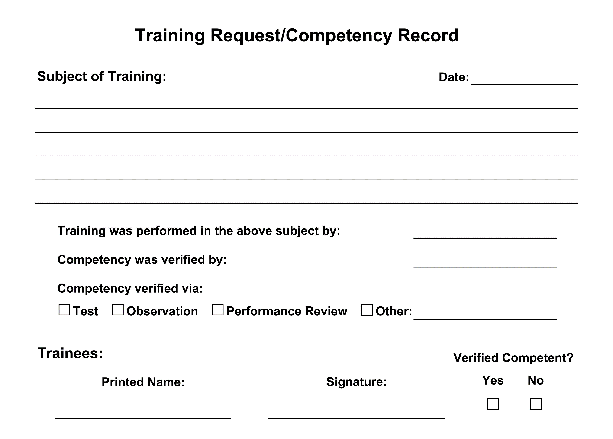

Procedure Statements
- Competency needs and training are discussed with new employees. Managers and Supervisors will review the training matrix and transcripts to determine what training will be necessary for transferred or promoted employees.
  - Onboarding curriculum is not required for training associates in promotions or transfers but should be utilized to identify additional needs or gaps in the new positions training requirements. Associate training status and/or transcripts in the LMS must be reviewed and meet competency to all current versions of process content. Reference the Training/Competency Requirements Matrix for needs by “Department based functions.”
- Temporary employees will be trained on the job they will be performing using the Temp Employee Packet provided by HR. Completed forms will be sent to hr@imsmetals.com.
- Training & Competency status of associates can be identified or assigned using the Training/Competency Requirements Matrix, associate transcripts in the LMS, and/or recorded TR001 captured trainings.
- Competency needs are identified during one or more of the following: Onboarding Curricula, CARs, Management Reviews, and when evaluating competency changes to the Quality Management System.
- Changes to Quality Management System requirements include changes to Quality Processes Manual (QSM), Procedures (QSP), Work Instructions (QSI) and Forms due to Corrective Action Requests, Process Improvement Requests, Safety process changes or equipment changes. Competency and understanding of all changes should be verified and recorded as trained within 30 days of the content revision date.
- Each department Supervisor or Manager, supported by the Branch General Manager, is responsible for providing employees with the company Quality Policy and for assisting them in understanding the policy and quality systems that support it. This includes understanding all QMS/ISO requirements and their application to an employees’ particular function. New employees receive onboarding training that provides them with an overview of the customer journey, explanation of the duties and responsibilities of internal customers and external providers, as well as witness departmental and cross-organization interactions to obtain and understand the required organizational knowledge of the company QMS.
- Verifying Competency
- Written tests of understanding of training topics will be administered as applicable to determine knowledge acquisition.
- When written tests are not performed, evaluate competency by observation and questioning while the employee is performing the trained task. Evaluations will be documented by a qualified individual.

Risks and Mitigations
Risks | Mitigations
Not properly defining employee’s job-related competency requirements through the use of training assessments and job evaluations. | Process Owner review of personnel to be trained per Process at each revision ensures that both the requirements and the evaluation of competency are current and effective.
Lack of documenting and communicating required job qualifications on company job descriptions or the skills matrix. | HR and Managing Members ensure that job descriptions are updated as needed to describe specific performance results and the skills and abilities required to accomplish those results.
Not performing a training needs analysis or skills gap analysis as intended. | Training needs analyses and skills gap analyses are ensured through the rigorous practice of competency assessments; corrective actions - particularly as required for any performance shortfall - and through the implementation of the Training/Competency Requirements Matrix.
Misinterpreting the results of, not understanding, or not taking action on a training needs analysis or skills gap analysis. | The practice of multiple rater input and cross-sharing of training processes will ensure that no one isolated person or group has sole knowledge of or access to training results; training gaps; or skills gaps.
Unable to provide evidence of employee abilities based on their education, training, skills, knowledge, experience for key positions. | A multi-tiered and diverse record-keeping process ensures that documentation of training and competency evaluation is recorded and logged in a permanent format and kept in a permanent repository.
Failure to verify competency has been met.  Not providing or scheduling enough quality time for an associate to spend on interdepartmental observations/OJT to meet the required organizational knowledge of the QMS. | Depending on the importance and safety sensitivity of a particular skill or body of knowledge, competency may be verified by qualified personnel other than immediate Supervisor and consistent practice will ensure proficiency over time.

Reference and Applicable Documents
Organizational Quality Processes Manual (QSM-9000)
Safety (QSP 19.1)
Training Request/Competency Record (TR001)
Training/Competency Requirements Matrix
Learning Management System (LMS)

Personnel to be Trained
Personnel that are determined to be impacted by this process shall require training in its effective implementation.

Revisions Table
Date | Description of Change | Approved by
12/13/21 | Updated and reformatted. Clarification of OB and records. Competency highlighted. Safety QSP reference added. | Melissa DaSilva  Auggie Huerta
TBD | TBD | TBD

